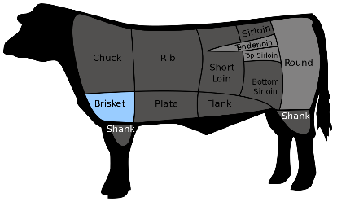Name____________________Hr___

**All About Beef: Web Search**

1. Go to the Kansas Beef Council webpage, [www.kansasbeef.org](http://www.kansasbeef.org). Click the “**Health and Wellness**” link in the black writing at the top. 🡪 Click “**What about Grass Fed Beef?**”

***DID YOU KNOW?*** (Define each term)

* 1. Monosaturated Fat:
  2. In Order to be Organic:
  3. Grain Finished Beef:

Beef contributes to ____ % or less of saturated fat and total fat.

Grain-Finished: _____ g Protein Grass-Finished: _____ g Protein

1. Go back to the homepage of the Kansas Beef Council. Click “In The Home” located at the top. Scroll down to click “Food Safety in the Home.” Click the Infographic on the right to expand the information. ***Define*** the grade of cuts.
   1. Prime:
   2. Choice:
   3. Select:
   4. Marbling:
2. Use the Food TV webpage and look up a beef rub or marinade that appeals to you:
   1. What was the recipe called?
   2. What type of meat/cut was used for this?
   3. 5 Basic Ingredients:
   4. One reason that picked this (besides that it looks good):
3. Beef Nutrients: Go to beefitswhatsfordinner.com 🡪 “Nutrition” 🡪 “Beef’s Nutrients” 🡪 **Label** the 10 nutrients in beef and their health benefit.
   1. Iron-
   2. Choline-
   3. Protein-
   4. Selenium-
   5. Zinc-
   6. Vitamins B6 and B12-
   7. Phosphorus-
   8. Niacin-
   9. Riboflavin-
4. Go to beefitswhatsfordinner.com🡪 On the left side, click “Cooking” 🡪 Click on each cooking technique to fill out the proper steps to each method

***\*\*\*Under Steps, provide an explanation!***

|  |  |  |
| --- | --- | --- |
| **Cooking Technique** | **Steps to Follow** | **Best Beef Cut** |
| **Grill** | 1.Choose-  2.Prepare-  3.Cook- |  |
| **Stir-Fry** | 1.Choose-  2.Prepare-  3.Cook- |  |
| **Stew** | 1.Choose-  2.Prepare-  3.Cook- |  |
| **Broil** | 1.Choose-  2.Prepare-  3.Cook- |  |

1. ***Analyze*** how your family chooses their beef cuts. Include at least three factors that are considered. Write these in a small paragraph in complete sentences.