**Vegetable Cuts and Dimensions**

**1/16 X 1/16 x 1 to 2 in**

**Fine Julienne**



**1/8 X 1/8 X 1 to 2 in**

**Julienne**





**¼ X ¼ X 2 to 2 ½ in**

**Batonnet**

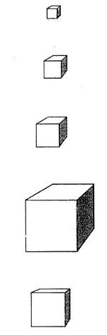

**½ X ½ X 1/8 inch**

**Paysanne**

**Small Dice**

**Large Dice**

**Brunoise**

**Medium Dice**

**¾ X ¾ X ¾ inch**

**¼ X ¼ X ¼ inch**

**½ x ½ X ½ inch**

**1/8 X 1/8 X 1/8 inch**