**Compound Butters**

Group # ____ Hr _____

A flavored butter that can be used for variety of dishes including, baked goods, steaks, rice, vegetables, etc.

1. Choose one type of flavor combination: SWEET SAVORY

**CIRCLE**

1. Choose up to 4 herbs and spices to complete your flavor profile:

Cinnamon Basil Rosemary Thyme Dill

Oregano Chives Ginger Nutmeg Cloves

Garlic Powder Onion Powder Turmeric Paprika Cumin

Cayenne Pepper Allspice Mint Parsley Cilantro

1. In a mixing bowl, using hand mixer, whip one stick of unsalted butter until fluffy. Add in ¼ teaspoon of each of the herbs/spices from above and whip until combined.
2. Transfer butter to a piece of waxed paper and form into a log. Label paper with hour and kitchen. Chill for 2 hours or until solid.

[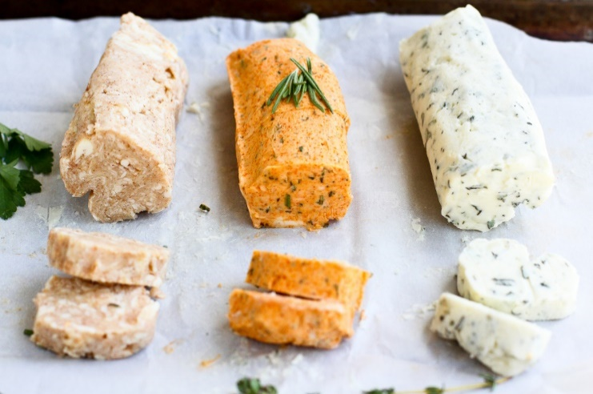](https://pioneerwoman.files.wordpress.com/2016/07/how-to-make-compound-butter-05.jpg)

*Tasting:*

1. What is an example of a dish that would be great with your compound butter?
2. Did your flavor combinations work together? EXPLAIN your reasoning.