**SPICE CAPADES**

Name______________________________ Hr___

1. Where do most of our culinary spices come from?
2. Spices and herbs contain essential, flavorful oils. In an herb, the oils are found in the ________________________ and in spices, the oils come from other botanical parts of the plant, such as _________________________.
3. Coriander plants generate what herb? ______________________ What are some dishes that this herb is added to?

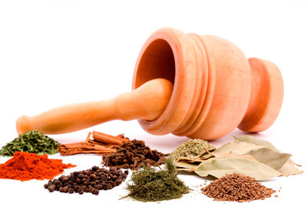

1. **Identify** spices that are found in the following forms:

Berry:

Seed:

Bark:

Pod:

1. Herbs can be used either fresh or dried, but spices can only be used in what form?
2. It is best to keep spices away from light, air, moisture and heat. What is the best kind of storage method?

1. Spices can be purchased either _________________ or ___________________.
2. For the best quality, what is the shelf life for spices?

**Whole:** **Dried:**

1. Most spices are consumed with other spices. Why is that?
2. What are two examples of spices that are a *prepared* mixture?
3. Describe the use of a mortar and pestle.
4. When should spices be added to cooking for maximum flavor?