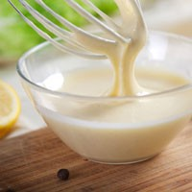Name_______________________Hr___

**Hitting the Sauce- Good Eats**

1. What is the term meant by fond?
2. How was the pan deglazed to remove the fond?
3. What liquids can be used to deglaze pan? (Give at least 2)
4. What is meant by the term reducing?
5. When should you season sauces?
6. Broth is made from meat and bones, while stock is made from only:
7. Describe how starches ***thicken***.
8. Name at least **four** starches that can be used to thicken?

A.

B.

C.

D.

1. How is starch dispersed into a hot liquid? Why is this done?
2. What is the advantage of using arrowroot?
3. What are disadvantages of using flour or cornstarch?
4. What are at least 5 ingredients in the sauce, Hollandaise?
5. Hollandaise sauce is cooked over ______________ water.
6. Explain the purpose of emulsifiers. (Ex. Eggs)
7. What are 2 foods that can be served with Hollandaise?
8. What is an easy way to keep sauce for later use?

